**NAMA : NIKEN NOVIARDIANA**

**NIM : 21.01.55.0017**

**UTS WEB SERVICE DEVELOPMENT**

1. **Membuat Database**

CREATE TABLE services (

id int(11) NOT NULL,

name varchar(100) NOT NULL,

duration time NOT NULL,

price int(15) NOT NULL,

category varchar(100) NOT NULL

) ENGINE=InnoDB DEFAULT CHARSET=utf8mb4;

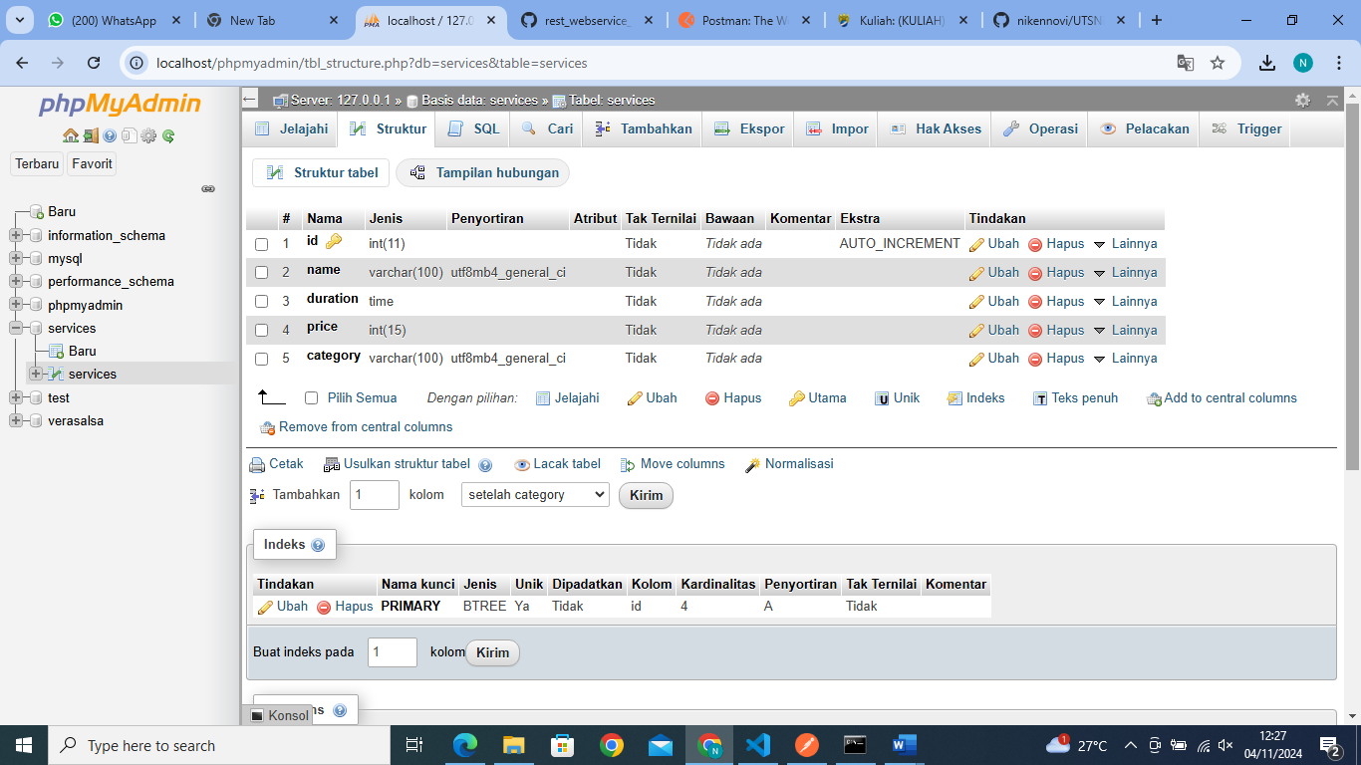

1. **Menambahkan data ke dalam table**

INSERT INTO services (id, name, duration, price, category) VALUES

(NULL, 'nail art polos', '01:30:00', '35000', 'kuku'),

(NULL, 'nail art motif 4', '01:30:00', '50000', 'kuku'),

(NULL, 'eyelash', '00:30:00', '75000', 'mata'),

(NULL, 'lashlift', '00:30:00', '40000', 'mata');

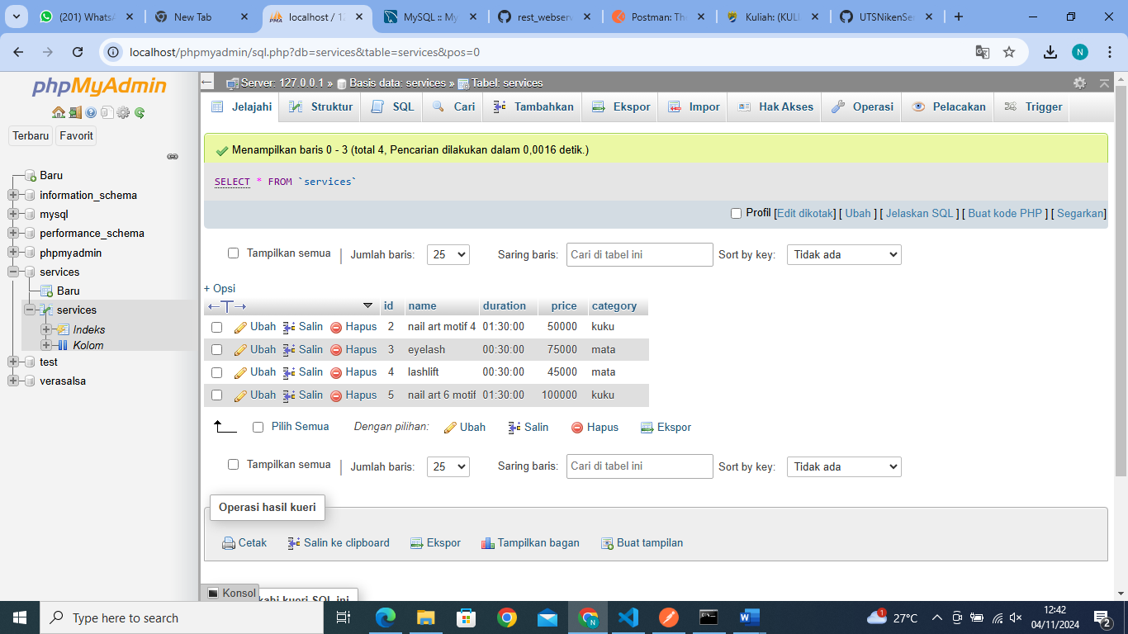

1. **Membuat File Di File C**

Membuat folder di dalam C-Xampp-Htdocs-services.php

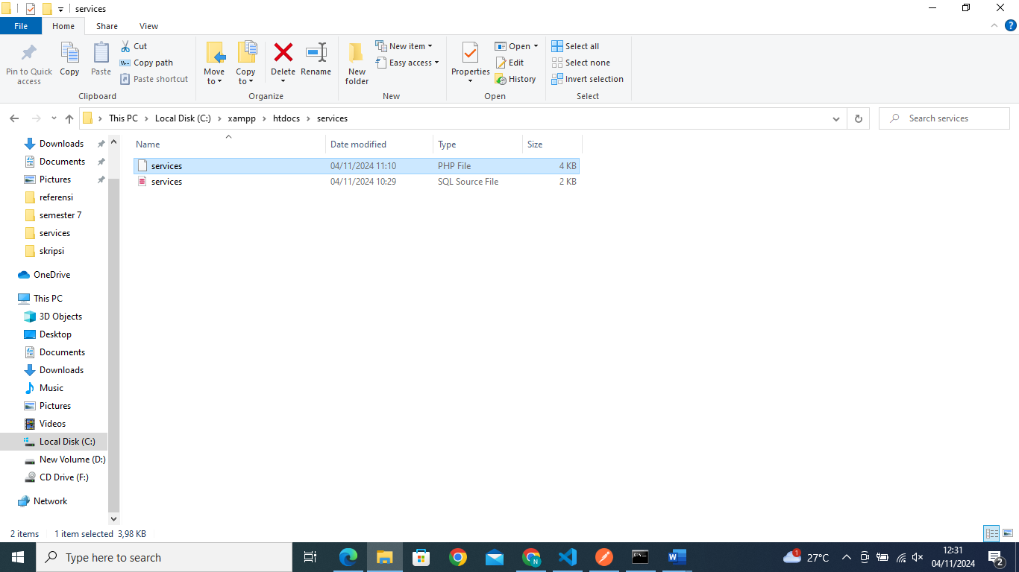

1. **Program yang ada pada services.php**

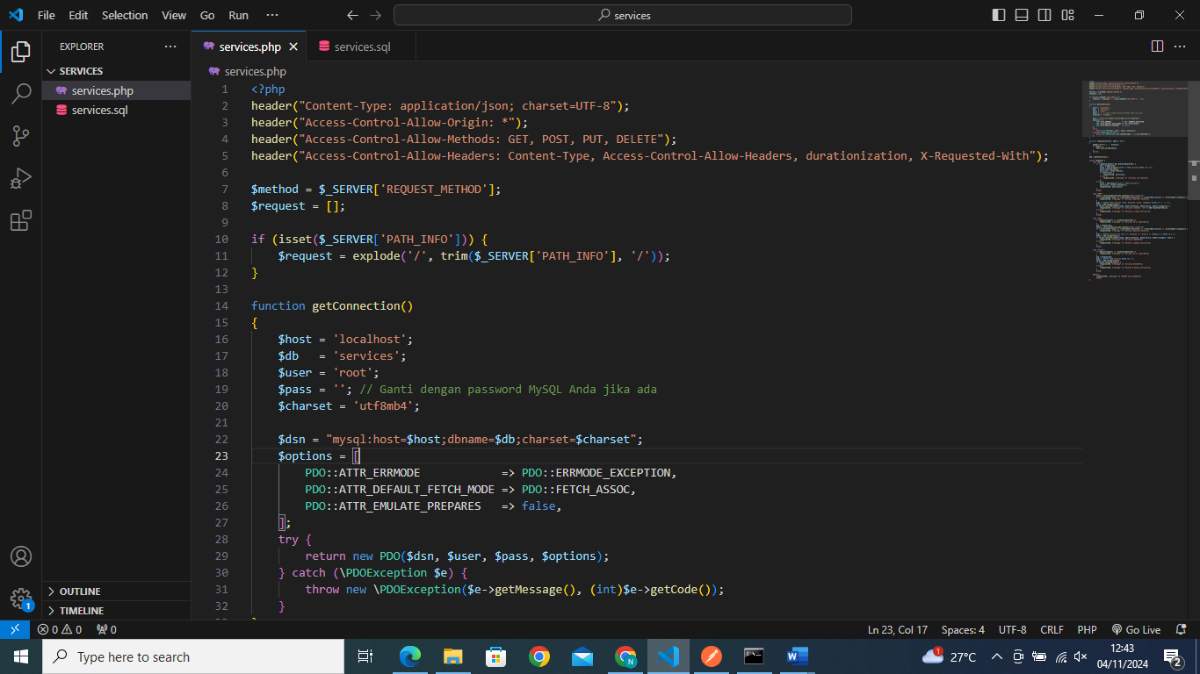

1. **Hasil untuk menampilkan seluruh data**

GET -> http://localhost/services/services.php

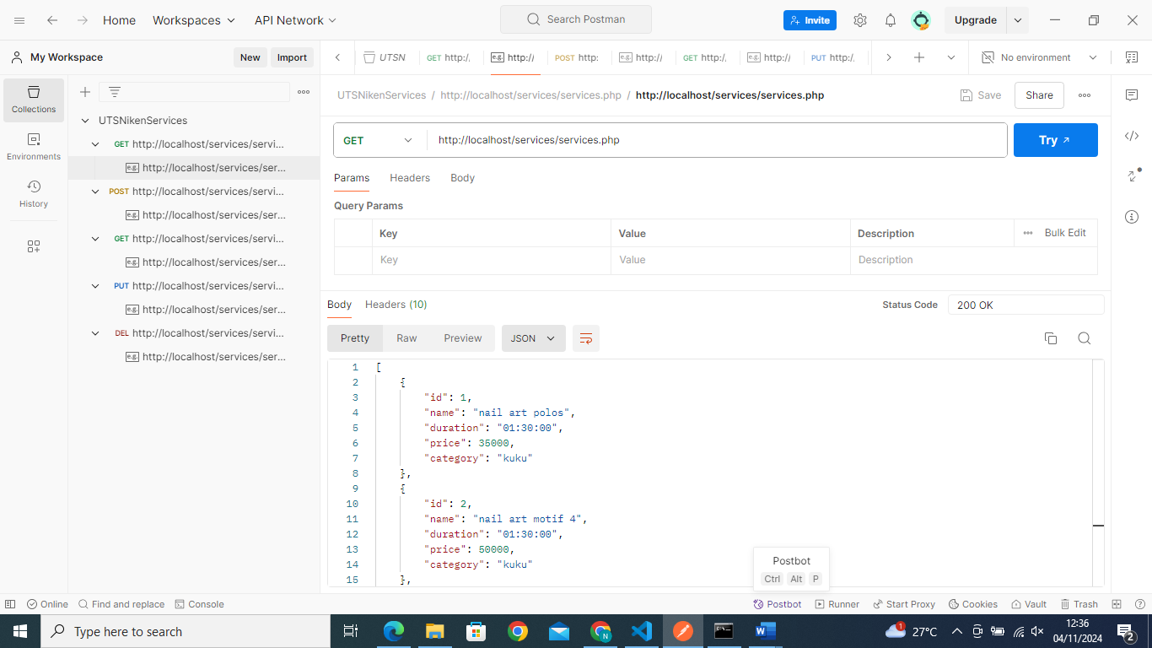

Di atas adalah hasil dari penampilan seluruh data pada mysql.

1. **Menampilkan database sesuai dengan id yang diminta beserta validasinya**

GET -> <http://localhost/services/services.php/3>

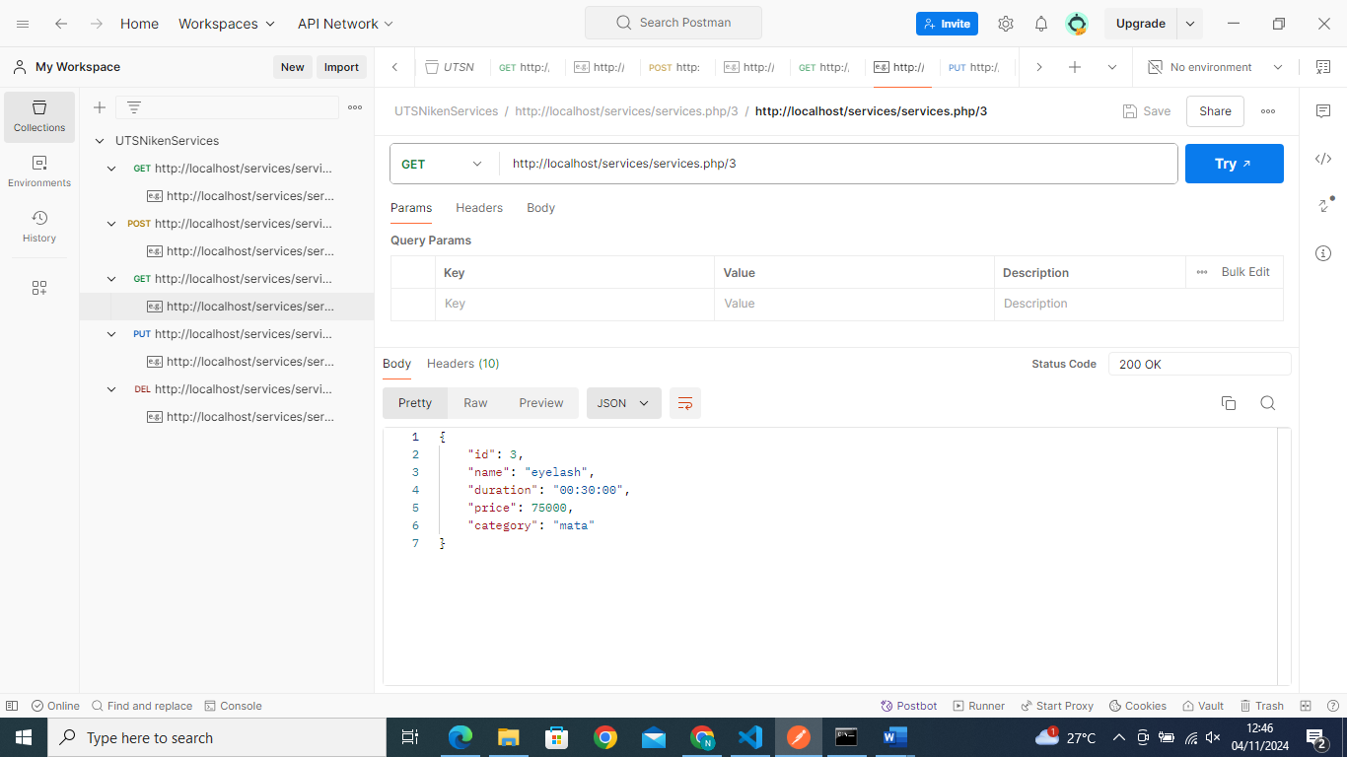

1. POST New Services

POST-> <http://localhost/services/services.php>

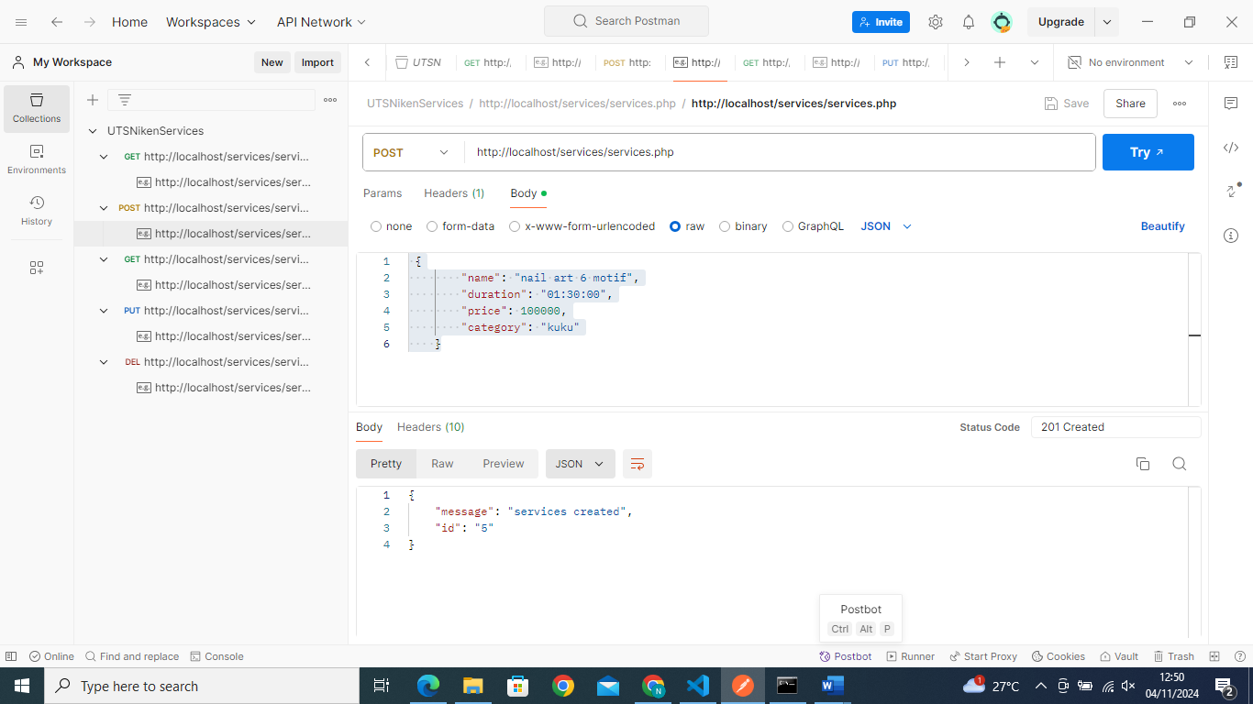

1. PUT

PUT -> <http://localhost/services/services.php/4>

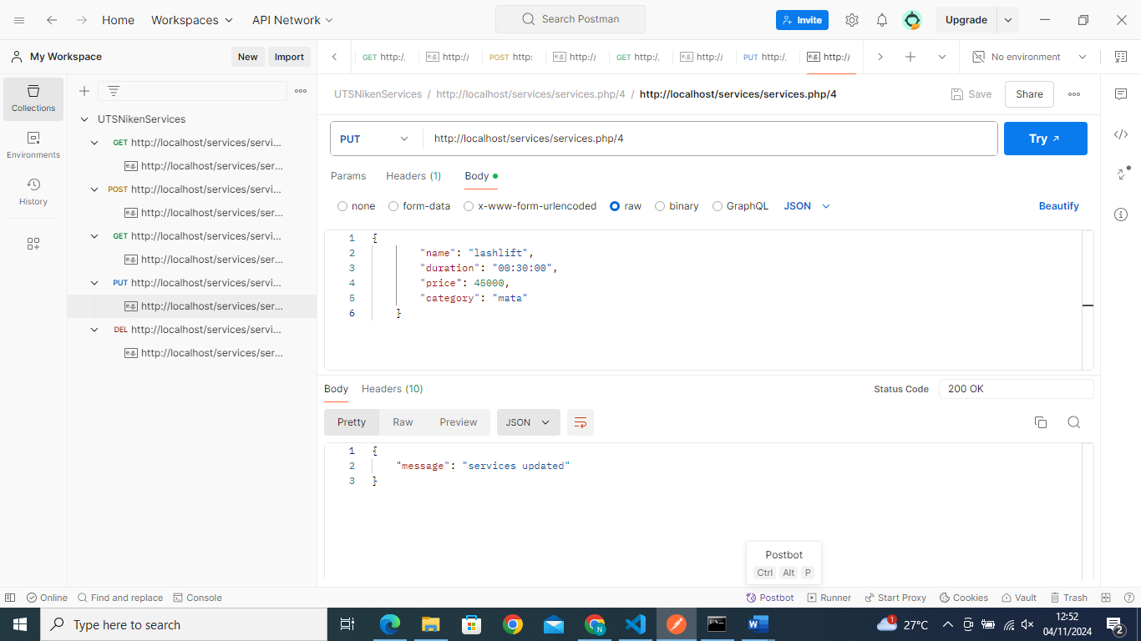

1. Delete

DELETE -> <http://localhost/services/services.php/1>

